Sampada| ;Dkbf| Heritage
]
[
• Property that is or may be inherited; an inheritance.
• Valued objects and qualities such as cultural traditions, unspoiled countryside, and historic buildings that have been passed down from previous generations:
the richness of our diverse cultural heritage | a sense of history and heritage.

Sampada is an event for promoting traditional and natural fabrics of Nepal, among young generation and international delegates to uplift these fabrics in national and international market.
Nepal itself is enriched with natural resources, by making full advantage of these natural resources, our ancestors used to make clothes to protect and cover their body.Many types of fabrics are produced it’s origins from nature like: alloo, hemp, nettle, banana, pashmina etc which are good for health and economic as well.
Now days, we rarely see people wearing traditional fabrics. The today’s generations are more fascinated towards western fabric outfits. It has been necessary to aware young generation about the grace of traditional and natural fabrics. In Nepal, there are many people living hand to mouth/ independently by utilizing natural resources in scientific way to produce fabrics. Even though, these fabrics are of good quality, due to lack of appropriate investment opportunity, awareness and rapid urbanization, proper judgment is not being possible in both national and international arena.
The designs according to the taste of young generation are not available in these fabrics. As well as the use of these fabrics in Nepali designers for their creativity are exceptional. Beside these, due to lack of proper mobilization and dissemination, these fabrics are being under noticed among people.
It is the matter of plight that new designs in these fabrics are hard to find in the market and to conserve our tradition, here we assure to present our fusion designs according to the taste of young generation and to uplift natural fabrics trade industry.

Objectives
- To introduce and elevate the fabrics originate in Nepal in both national and international market.
- To initiate conservation of traditional Nepalese fabrics.\
- To uplift natural fabrics trade industry.
- To present natural fabrics among young generation.

Expected results
- Economic empowerment.
- Attraction of young generation towards traditional and natural fabrics.

Promotional Marketing & Activities Plan
Sampada utilizes a combination of marketing platforms which include: Direct Mail, Radio & Television Broadcasting, Outdoor Advertising, Local Cable Spot Ads through local Cable Service Providers, Print Media (official newspaper) and upscale print publications (magazines). In addition, we also utilize our email requests for additional show information and conducts SMS blasts via constant contact 2-3 weeks prior to the show.

Inspiration | tradition Nepali fabric, (ceremonial, ethnical, cultural, etc)
Fabric Use | Dhaka, Aollo, linen, Nepali Silk, hemp with mixing with another fusion fabric, Georgate, Net, chiffon etc
Target people | professionals, expatriates, diplomats, business man, traders – exporters/importers,celebrities, models
Line | straight, circular, A-line, various cuts etc
Colour | multi colour which is naturally finds in Nepalese handloom fabrics.
Ornamentation | traditionally fused ornaments
Wear | party wear, casual wear, mix wear, executive wear, wedding wear etc

Theme of the fashion show

1st sequence
Traditional Twist
About theme: It is the element where eastern and western culture meet and influence each other with versatile of design, which presents the love and beauty of eastern dresses and western dresses in combined way.

2nd sequence
Cultural Fusion
About them: it is twist in the design but in traditional fabric and handloom fabric with modern design, which is mainly fusion towards young generation.
3rd sequence
Ethnic flavor
About theme: the flavor, which gives the test of ethnicity of Nepali organic fabric. Ethnicity don’t have boundary so it can be used in the executive wear with the flavor and ethnic prints.
4th sequence
SamyeBaji
About theme: the mix or various designs just like samyebaji with the various tests in samyebaji everything is presented in one plate likewise various designs, colours, fabrics, prints etc are presented with the flavor of Nepalese home production.
5th
Wedding (Pancheybaja) sequence
It gives the significant of wedding. It is all about the various cultural wedding dresses in a new taste/new style with old traditional looks.
6th sequence
Tribute’s to Royal (Monarch)
This sequence is tribute to the hype creator fashion, which is done by the Royal family of Nepal. The way of their styling of the fabrication and the charmness of the works done and embroideries in fabrics, costumes which are mostly found in the Royal family members wearing dress.

TYPES OF SPONSORSHIPS
The need to reach the right customers, claim an appropriate product & service positioning and make a line-up of potential customers in plenty could be any sponsor’s desire. This need is more pronounced in the educational sector given the fact there is only a few outlets to do so at the moment in Nepal.
Sponsorship impacts on the visitor more powerfully than any other tool. It is a direct cost-effective route to your target market. You are invited to take advantage of a number of distinctive packages. The opportunities are diverse and vary in price and style, to appeal to a wide range of exhibitors who wish to raise their profile at the show.
Our sponsors and business affiliates shall be provided with the sponsorship opportunities as dealt in pages to follow:

Title Sponsor Offers:: NRs 6,00,000.00
The Title Sponsor of the event benefits includes title recognition, promotion and participation before, during and after the event.
Pre-Event
* Recognition as Title Sponsor
* Company logo and recognition as Title Sponsor in the event brochure / handouts / promotional materials.
* Short speech during the Press Conference of the event.
On-Event Complimentary Offer
* 12 square meter stand at event location to display your banner, product and information.
* 50 complimentary invitation cards

Main Sponsor Offers: NRs. 4, 50,000.00
The Main Sponsor of the event benefits includes recognition, promotion and participation before, during and after the event.
Pre-Event
* Recognition as Main Sponsor
* Company logo and recognition as Main Sponsor in event brochure / handouts / promotional materials.

On-Event Complimentary Offer
* 6 square meter stand at event location to display your banner, product and information.
* 30 complementary invitation cards

Co Sponsor Offers: NRs. 3, 00,000.00
The Co Sponsor of the event benefits includes recognition, promotion and participation before, during and after the event.
Pre-Event
* Recognition as Co Sponsor.
* Company logo and recognition as Co Sponsor in event brochure/ handouts / promotional materials.
On-Event Complimentary Offer
* Company banner display at selected space
* 10 complementary invitation cards

Official Sponsor Offers: NRs. 1, 00,000.00
The Official Sponsor of the event benefits includes recognition; promotion and participation before, during and after the event
Pre-Event
* Recognition as Official Sponsor.
* Company logo and recognition as Official Sponsor in event brochure/ handouts / promotional materials.
On-Event Complimentary Offer
* Company banner display at selected space

SPONSORS’ SCALABLE RETURNS| Sampada|
By getting involved in this event, our sponsors will be able to leverage their corporate contribution directly to event visitors and indirect audiences and therefore find themselves with increased visibility and remembrance in the millions of hearts and minds.
Sponsors will reach about to an audience of enthusiastic visitors within 30-day promotional campaign, before, during and after the event, via both national and local press and electronic media. Reaching both clients and potential clients your organization shall gain the following:
• Increase your corporate identity/brand equity
• Increase branding opportunity
• Increase sales revenue
• Grab media attention
• Develop new Markets
• To develop community relations
• Increase customer share of heart and mind
• An opportunity to associate with “Higher Education & Career Fair” for longer relations ahead.
• Pull about your desired and potential clients to associate your identity with your educational objectives

STILL OTHER WAYS TO GETTING INVOLVED
The other ways to getting involved besides regular and package sponsorship opportunity with the event can be from among the following in kind sponsorship.
(Please call our executive for the further discussion)
1. Invitation/Tickets
2. Advertisement print
3. Road danglers
4. Backdrop/Display board
(Note: Inkind sponsors will get 20% of the space in any of the print materials they sponsor, they can either print the material themselves after getting the design approved or we will do the needful and charge separate to your organization)

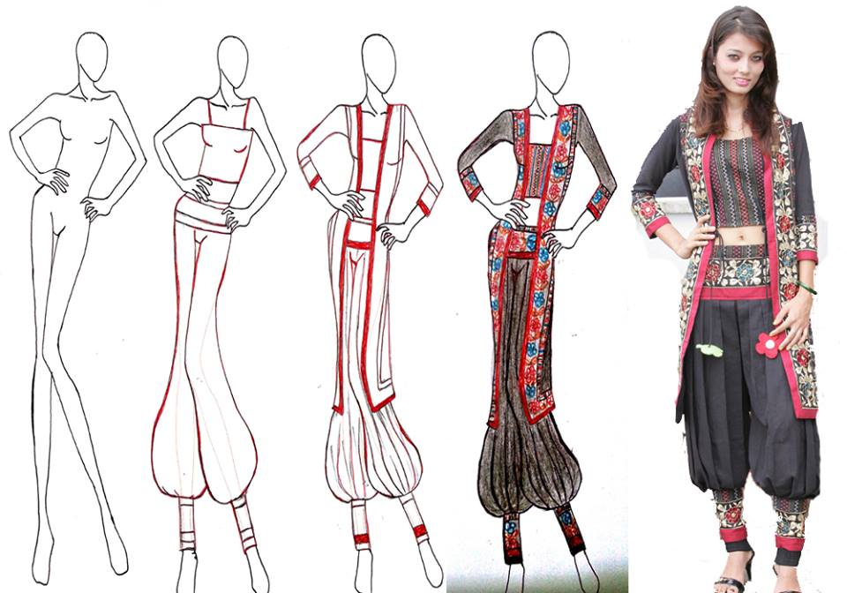
About Us:
DIRECTION NEPAL P. Ltd
Vision Statement:
“To develop best tools, practices and opportunities in the field of event management in
Order to constructively contribute towards the overall enhancement of the country”

Direction Nepal P. Ltd is the uniquely conceptualized professional event management company that aims to efficaciously meet the requirements of today’s market driven economy.

Since its inception (2002), Direction Nepal has been making initiations to combine substantial industry experience, reputation and relationships to lay the groundwork to develop and organize integrated programs in the event management industry in Nepal with the proven capability to provide creative, feasible, efficient, meticulously planned and successful programs. Each of these exhibitions, programs and events is unique in its core nature and requires customized, logistic and strategic partnership with the concerned stakeholders. Our cosmopolitan, dynamic and talented teams are committed to provide just that.

Shama Banu: Fashion Designer

Shama Banu is a very well-known designer in Nepali Fashion Industry as well as Kollywood, the Nepali Film Industry. Shama introduced a new concept of fashion designing in Kollywood when she designed the costumes for the movie ‘Kathmandu’. She was more inclined towards the creative field and wanted to create a niche for herself in this field. Hence, Shama followed her passion for the fashion industry and joined Namuna College of Fashion Technology (NCFT) in 2006. Since then Shama has never had to look back and has earned the distinction of “The Transformer” of the characters’ look. Shama’s designs are powerful enough to express the characters without having them to utter a single word. Shama is a simple person who envisioned a dream, had a plan and worked very hard to pursue it. However, she is not done yet as she believes there is much more she wants to achieve. As they say, sky is the limit for someone as talented and willing to succeed as her.
Shama has achieved a tremendous appreciation. Her work has been honored with various awards. Shama is continuously delivering quality work for her fashion boutique ‘Shamas Creation’. There is definitely much more to be expected from this budding star full of passion for her work in the near future.

Riteish Ghimire: Fashion Designer
History:-
Started Diploma from IEC
After completing Diploma in fashion Designing, went to Italy for pursuing further studies. He started his Undergraduate in Fashion Designing at Polimoda International Institute of Marketing & Fashion Design University in 2011.
He have been working in 3 companies with other team of Fashion Designer and have store outlet in Cereto, Frank- furt, the collection of his design in different fabrics and Nepali fabric such as Hemp, Fell, Allovera, Banana- Cotton fabric etc.
Worked with in different Boutique & company code dress as a free- lancer Designer.
He has done his designed Dresses personally to people who have ordered the costume which have exhibited in college event & fashion workshop.
He had taken part in Italy/ Paris Inter- Nation Fashion Week 2012 and designed mostly suits for men wedding, gown casual wear for NRN of Italy & local peoples of there.
He has been working for 3 online store partners of Fashion Market to give them the design of costumes of order.
Have team workshop for fashion store through where his product has been designed from there and launching to the Fashion store of selected retail place.
He has two years contract at Newyork / Italy Fashion week team member. To provide them with his design that is touched with Nepali fabric such as Hemp, Pashmina, Felt, Dhaka, Banana cotton etc. till 2016.
His designs have gone till Rajasthan of India and for lakme Fashion week of India through styligion team crew members.

Mark your calendar for | Sampada|

Thursday, 13th September 2013 (27 Bhadra 2070)
1905, Kantipath, Kathmandu

For Further Details:
Mr. Mahesh Khadgi: :
Manager- Events & Marketing phone + 977 1 4259976
Direction Nepal P. Ltd mobile +977 9851089578
Ganeshthan, Kamaladi email Mahesh@directionnepal.com
Kathmandu Nepal info@directionnepal.com

Ms. Shama Banu:
Designer phone + 977 1 4259976
mobile +977- +977- 9813355418
email: designer.shama@gmail.com

Mr. Sijan Maharjan:
Choreographer phone + 977 1 4259976
Mobile+ 977- 9841454229
Email: mcezen@yahoo.com

Mr. Ritiesh Ghimire
Designer phone + 977 1 4259976
mobile +977- 9849337541
email: akariteshghimire@gmail.com

